10.1.2 Reversing a String
Algorithm
Step 1 :- Start
Step 2 :- Define a function
Create a function named reverse_string(input_string).
Step 3 :- Initialize empty string
Inside the function, create an empty string x = to store the reversed string.
Step 4 :- Find length of string
Calculate the length of input_string and store it in variable 1.
Step 5 :- Traverse string in reverse
Use a loop from index 1-1 to 6 (decreasing order).
Step 6 :- Build reversed string
In each iteration:
Take character from input_string[i]
Append it to string x
Step 7 :- Return result
After the loop ends, return the reversed string x.
Step 8 :- Take user input
Outside the function, read a string from the user and store it in user_input.9. Call the function
Call reverse_string(user_input) and store the result in result.
Step 9 :- Display original string
Print: "Original String: " along with user_input
Step 10 :- Display reversed string
Print: "Reversed String: " along with result
Step 11 :- Stop

Flowchart
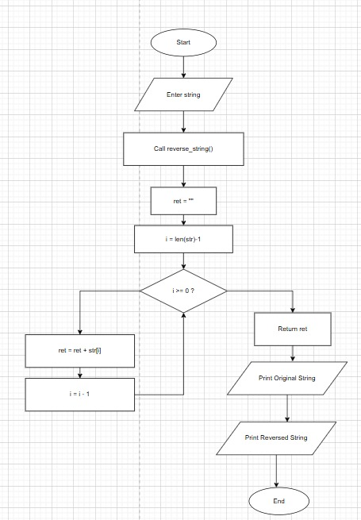

PYTHON CODE
def reverse_string(user_str):
re = ""
l = len(user_str)
for i in range(l-1,-1,-1):
re += user_str[i]
return re

user_input = input("Enter a string: ")
result = reverse_string(user_input)
print(f"Original String: {user_input}")
print(f"Reversed String: {result}")
EXCECUTION
